High Performance Door Rapid Protect 100  (High Speed Door) The door for Material handling |  | 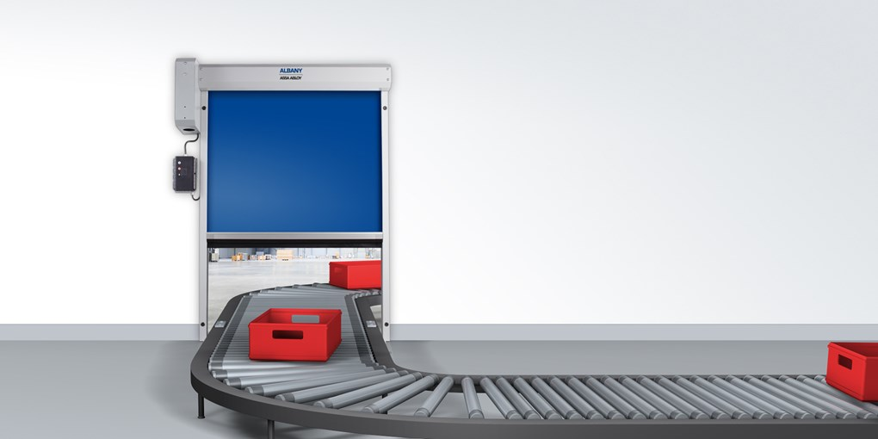
Door type | RP100 |  | PL. indicate your requirement
Description | Flexible high performance door, opening in vertical direction, for use in material handling, e.g.: conveyor belts and driverless transport lock
Side frames | Made of galvanized steel, 60 mm.
Door curtain | Travitop 1.3 mm in color: Blue (similar RAL 5010)  Grey (similar RAL 7035) or  Red (similar RAL 3002).
Opening / closing speed | Max. 0.9/0.9 m/s
Top Roll | Made of Aluminum
Bottom profile | Anodized aluminum
Drive unit | Electric motor with worm gear 0.37 KW potential free signals for door open/closed.
Protection | IP 55
Control unit | ACS 25 with standard functions in PVC housing
Control voltage | 24 V DC
Supply voltage | 3(N)PE/400; 50/60 Hz, 10 A (customer)
Safety devices:
As the door was developed for the use in machinery no safety devices for passenger traffic are supplied as standard. According to the machinery directive the door is regarded as machine. The operator is responsible for separating safety devices.

Size max | (DW x DH) 3000 x 3000 mm, max. 6 m²
Make | ALBANY Rapid Protect 100
Optional | - Cover :Top roll cover, galvanized steel  - Motor cover :PVC grey (RAL 7040) for drive unit with basic or without control unit  - Motor cover : powdered steel (RAL 9006) for basic control with frequency converter or chain drive
Alternative door Curtain | Curtain 1.3 mm with vision panels, vision panels max. 560 mm distance from lower edge of vision panels to top of floor ≥ 500 mm. vision panels only for DH ≥ 750 mm.  Colors: blue (RAL 5010), grey (RAL 7035), red (RAL 3002)
Curtain levels | Cut-out in the curtain for one panel, opening left or right. For stabilization a bottom profile is installed on the top edge of the level. The clear opening height is reduced by the height of the level.  Distance from lower edge of the vision panel to top of floor ≥ 500 mm + height of curtain level Height of level: 200 – 1000 mm (max. DH-200) Width of level: 400 mm – (DW – 400 mm)
X level | In case the door is completely integrated in the machinery the side frames can be extended from the lower closing edge to the floor. (X = distance between closing edge and floor).  The side frame can be extended from the lower closing edge to the floor by (DH + X) ≤ 4000 mm.
X level filling | In case the side frames are extended the open area underneath the machinery can be filled with a grey RollTex panel (color similar RAL 7001). X › 50 mm
Control unit | Door with standard control unit and frequency converter 0.85 KW, located at the drive unit.  Supply voltage: 1(N)PE 230V; 50/60 Hz or 3/N/PE 400V, 50/50 Hz, opening / closing speed max.: 1.8 / 1.1 m/s  The control unit can be equipped with a module for fault reports.
Safety devices for the main closing edge | Door line photocell integrated in the side frames  Electrical self-monitoring safety edge
Miscellaneous | Delivery ,Installation incl. wiring

